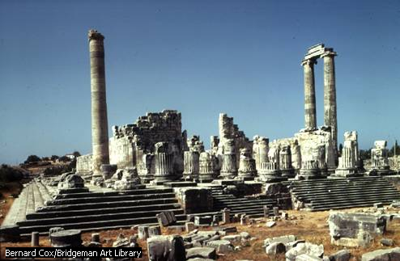

The Greeks built the Temple of Apollo at Didyma, Turkey (about 300 BC). The temple supposedly housed an oracle who foretold the future to those seeking knowledge. The predictions of the oracles, delivered in the form of riddles, often brought unexpected results to the seeker. With Ionic columns reaching 19.5 m (64 ft) high, these ruins suggest the former grandeur of the ancient temple.
Bernard Cox/Bridgeman Art Library

"Temple of Apollo at Didyma," Microsoft® Encarta® Encyclopedia 99. © 1993-1998 Microsoft Corporation. All rights reserved.

